**What is <div> in HTML?**

* <div> stands for **division**.
* It is a **non-semantic** container used to **group HTML elements** together.
* Commonly used for **layout and styling** using CSS.
* It **does not carry meaning** about the content it wraps.

**Example:**

<div style="background-color: lightblue;">

<h2>About Us</h2>

<p>This is a company overview.</p>

</div>

1. **HTML4 Version Using Only <div> (Non-semantic)**

<!DOCTYPE html>

<html>

<head>

  <title>HTML4 Layout</title>

</head>

<body>

  <div style="width: 300px; margin: auto; border: 2px solid black;">

    <div style="background-color: pink; border: 1px solid black; text-align: center; padding: 10px;">&lt;header&gt;</div>

    <div style="background-color: pink; border: 1px solid black; text-align: center; padding: 10px;">&lt;nav&gt;</div>

    <div style="display: flex;">

      <div style="background-color: pink; border: 1px solid black; text-align: center; padding: 10px; width: 60%;">&lt;section&gt;</div>

      <div style="background-color: pink; border: 1px solid black; text-align: center; padding: 10px; width: 40%;">&lt;aside&gt;</div>

    </div>

    <div style="background-color: pink; border: 1px solid black; text-align: center; padding: 10px;">&lt;article&gt;</div>

    <div style="background-color: pink; border: 1px solid black; text-align: center; padding: 10px;">&lt;footer&gt;</div>

  </div>

</body>

</html>

**Output:**

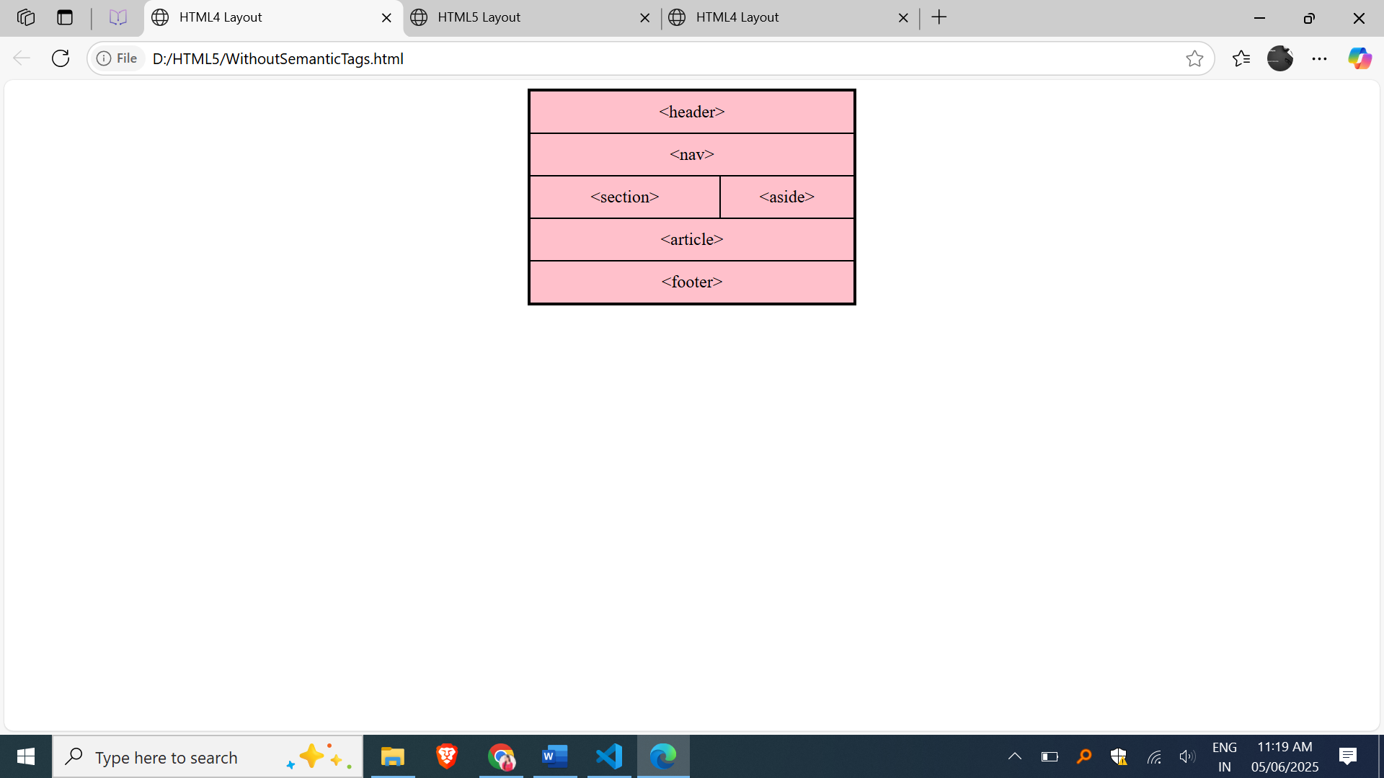

**HTML5 Version (Using Semantic Tags with Inline CSS)**

| Tag | Purpose | Example |
| --- | --- | --- |
| <header> | Contains introductory content or nav | Website logo and nav menu |
| <nav> | Contains navigation links | Home, About, Contact links |
| <main> | Contains main content of the document | Main article or page content |
| <article> | Independent self-contained content | Blog post, news article |
| <footer> | Footer info like contact or copyright | © 2025 All rights reserved |

**Example**

<!DOCTYPE html>

<html>

<head>

  <title>HTML5 Layout</title>

</head>

<body>

  <div style="width: 300px; margin: auto; border: 2px solid black;">

    <header style="background-color: pink; border: 1px solid black; text-align: center; padding: 10px;">&lt;header&gt;</header>

    <nav style="background-color: pink; border: 1px solid black; text-align: center; padding: 10px;">&lt;nav&gt;</nav>

    <div style="display: flex;">

      <section style="background-color: pink; border: 1px solid black; text-align: center; padding: 10px; width: 60%;">&lt;section&gt;</section>

      <aside style="background-color: pink; border: 1px solid black; text-align: center; padding: 10px; width: 40%;">&lt;aside&gt;</aside>

    </div>

    <article style="background-color: pink; border: 1px solid black; text-align: center; padding: 10px;">&lt;article&gt;</article>

    <footer style="background-color: pink; border: 1px solid black; text-align: center; padding: 10px;">&lt;footer&gt;</footer>

  </div>

</body>

</html>

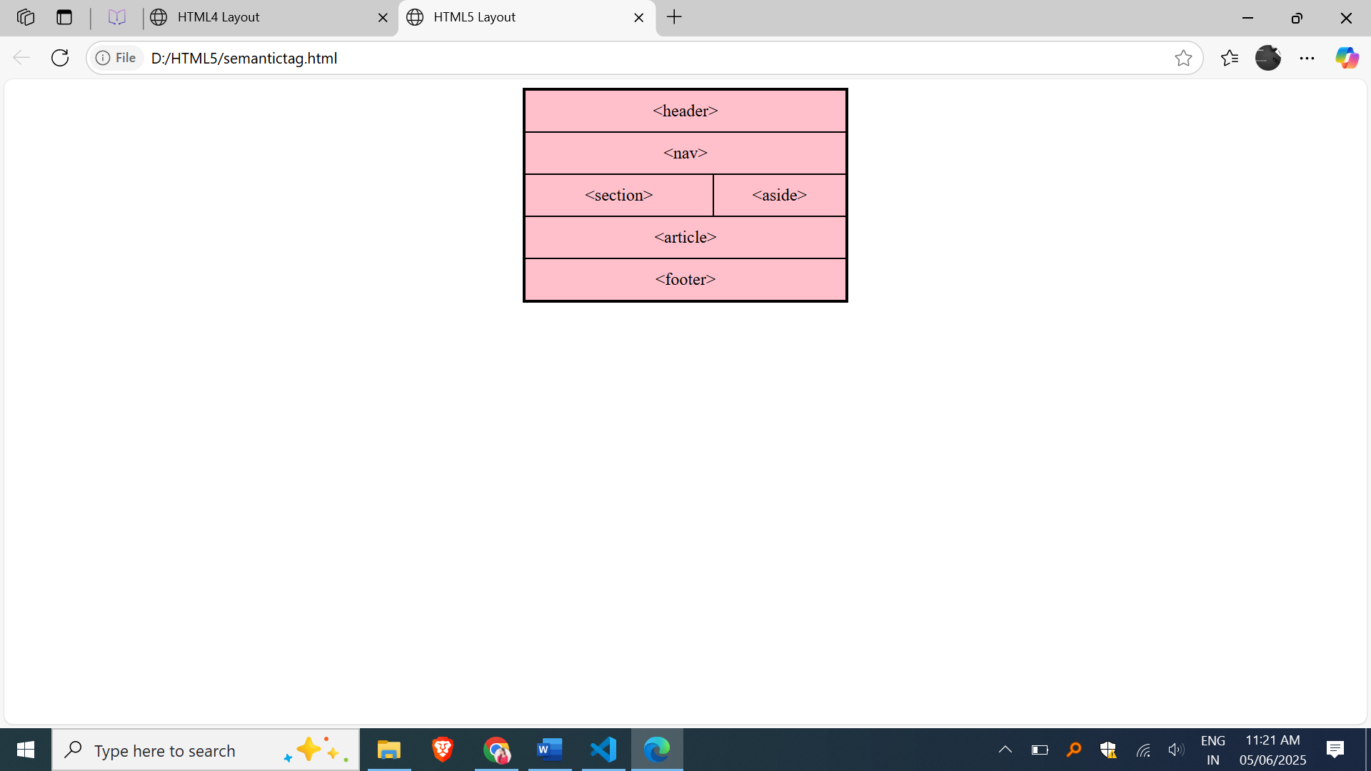

**Difference between HTML4 and HTML5**

| **HTML4 (div)** | **HTML5 (Semantic Tags)** |
| --- | --- |
| Uses only <div> with IDs or styles | Uses tags like <header>, <nav>, etc. |
| No clear meaning for content areas | Tags explain their content purpose |
| Harder for SEO and screen readers | Easier for SEO and accessibility |

Examples:

